## *BUILDING A SMARTER AI-POWERED SPAM CLASSIFIER*

***Phase 4 submission document***

***Project title: Building a smarter AI-powered spam classifier***

***Phase 4: Development part 2***

***INTRODUCTION:***



***Building a Smarter AI-Powered Spam Classifier***

A spam classifier is an artificial intelligence system designed to differentiate between legitimate, or "ham," messages and unwanted, unsolicited, and potentially harmful "spam" messages. The goal of a spam classifier is to filter out spam, allowing users to focus on relevant and safe communication.

This project aims to delve into the intricate process of building a smarter AI-powered spam classifier. While conventional spam filters have proven effective to some extent, the ever-adaptive nature of spammers necessitates a more intelligent, dynamic, and efficient solution. By harnessing the power of AI and machine learning, we can enhance the accuracy and adaptability of spam classifiers.

This includes data collection, preprocessing, model selection, training, evaluation, and deployment. Furthermore, we will explore ethical and privacy considerations, as well as the importance of continuous monitoring and improvement in response to new spam tactics.

you will have the knowledge and tools to create a highly effective and adaptable system for keeping unwanted messages at bay, safeguarding both individuals and organizations from the incessant deluge of spam.

***To build a smarter AI-powered spam classifier***

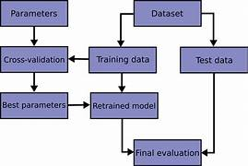

To build a smarter AI-powered spam classifier, you can employ advanced techniques and strategies. Here's how to proceed in this phase:

1. ***Advanced Text Preprocessing:***

Improve text preprocessing techniques to handle nuances in spam messages. Advanced methods may include:

- ***Lemmatization and Stemming:*** Reducing words to their root forms can help improve feature extraction.

- ***Handling Emoji and Special Characters***: Some spam messages use emojis or special characters for obfuscation. Consider how to preprocess and handle these.

***2. Feature Engineering:***

Enhance feature engineering techniques for more discriminative features. Explore:

- Feature Engineering for Multilingual Texts: If your dataset includes multiple languages, consider language detection and language-specific preprocessing.

- Meta-features: Extract features like message length, number of URLs, or presence of specific keywords.

1. ***Advanced Machine Learning Models:***

Experiment with more advanced machine learning models or deep learning approaches:

- Recurrent Neural Networks (RNNs): RNNs can capture sequential patterns in text data.

- Transformer Models: Explore transformer-based models like BERT, GPT, or RoBERTa for superior performance.

1. ***Hyperparameter Tuning:***

Fine-tune hyperparameters for your chosen model or models. Use techniques like Bayesian optimization for efficient tuning.

1. ***Cross-Validation:***

Implement k-fold cross-validation to assess the model's robustness and to estimate its generalization performance accurately.

***6. Handling Unseen Words:***

Utilize subword embeddings (e.g., FastText) or character-level models to handle out-of-vocabulary words and provide better generalization.

***7. Transfer Learning:***

Leverage transfer learning from large pre-trained language models. Fine-tuning a model like BERT on your spam classification task can lead to significant improvements.

***8. Model Interpretability:***

Enhance model interpretability using techniques like SHAP (SHapley Additive exPlanations) or LIME to explain model predictions.

***9. Continuous Learning:***

Implement a mechanism to adapt to evolving spam techniques. Periodically update your model with new spam examples to keep it effective.

***10. Deployment and Integration:***

Deploy the smarter AI-powered spam classifier in real-world scenarios. Integrate it with SMS services, email platforms, or other relevant applications.

***11. User Feedback Loop:***

Incorporate a feedback loop for users to report false positives and false negatives. Use this feedback to continuously improve the classifier.

Building a smarter AI-powered spam classifier is an ongoing process. Regularly evaluate its performance, monitor its accuracy, and adapt to emerging spam tactics. Ensure that you address ethical considerations, data privacy, and data security when deploying the model in a production environment.

***Machine learning algorithm:***



Selecting the right machine learning algorithm is a crucial step in building a smarter AI-powered spam classifier. The choice of algorithm can significantly impact the model's performance. Here are several machine learning algorithms to consider:

1. ***Multinomial Naive Bayes (MNB):***

- Advantages:MNB is simple and efficient, making it a good choice for text classification tasks. It often performs well with relatively small amounts of data.

- Considerations: It may not capture complex relationships in the data as effectively as more advanced algorithms.

1. ***Support Vector Machines (SVM):***

- Advantages: SVMs can handle both linear and non-linear classification tasks. They are effective at finding complex decision boundaries.

- Considerations: SVMs might require more computational resources and tuning compared to simpler algorithms.

***3.Random Forest:***

- Advantages:Random Forest is an ensemble method that combines multiple decision trees, offering robust performance and good generalization.

- Considerations: It can be computationally expensive and might require fine-tuning.

***4.Logistic Regression:***

- Advantages: Logistic Regression is a straightforward and interpretable model. It's a good choice for a simple baseline classifier.

- Considerations: It may not capture complex non-linear relationships as well as some other algorithms.

***5.Gradient Boosting (e.g., XGBoost, LightGBM):***

- Advantages: Gradient boosting methods are powerful and can achieve high performance by combining weak learners.

- Considerations: They can be computationally intensive and require careful hyperparameter tuning.

1. ***Neural Networks (Deep Learning):***

- Advantages: Deep learning models, such as Recurrent Neural Networks (RNNs) and Transformer-based models (e.g., BERT), have shown state-of-the-art performance on various text classification tasks.

- Considerations: Training deep learning models requires a substantial amount of data and computational resources.

1. ***Ensemble Learning:***

- Advantages:Combining multiple models, such as using a voting classifier, can improve overall performance and robustness.

- Considerations:It might increase model complexity and training time.

1. ***Hybrid Models:***

- Consider combining multiple algorithms or using a two-stage approach. For instance, you could use an initial model to filter out the most obvious spam messages and a more sophisticated model to classify the remaining messages.

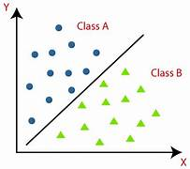

When selecting an algorithm, consider factors such as the size of your dataset, computational resources, the complexity of the problem, and your specific objectives. It's often a good practice to start with a simple and interpretable model (e.g., Multinomial Naive Bayes or Logistic Regression) and then gradually experiment with more complex models as needed.

Additionally, for text classification tasks like spam detection, leveraging pre-trained language models (e.g., BERT, GPT) and fine-tuning them on your specific task can yield impressive results. These models have the advantage of capturing semantic relationships in text data.

Ultimately, the choice of algorithm should align with your project's goals and resources. It's also important to assess the model's performance through rigorous testing and cross-validation to ensure it meets your accuracy and efficiency requirements.

***TRAIN THE MODEL:***

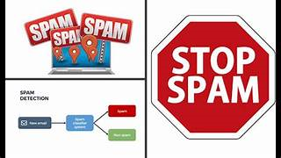

Training a smarter AI-powered spam classifier involves several steps. In this example, we'll assume you are using a machine learning algorithm like Multinomial Naive Bayes. Here's how to train the model:

1. ***Preprocessed Text Data:***

Make sure you have preprocessed the text data as described in the earlier phases, including text cleaning, tokenization, and TF-IDF vectorization.

1. ***Split the Data:***

Split your preprocessed data into a training set and a testing set. This allows you to evaluate the model's performance.

python

from sklearn.model_selection import train_test_split

X = preprocessed_data # Replace with your preprocessed text data

y = labels # Replace with your corresponding labels (0 for non-spam, 1 for spam)

X_train, X_test, y_train, y_test = train_test_split(X, y, test_size=0.2, random_state=42)

1. ***Choose the Algorithm:***

Select the machine learning algorithm you want to use for your spam classifier. In this example, we'll continue with Multinomial Naive Bayes.

python

from sklearn.naive_bayes import MultinomialNB

classifier = MultinomialNB()

***4. Train the Model:***

Fit the chosen classifier on the training data.

python

classifier.fit(X_train, y_train)

1. ***Evaluate the Model:***

After training the model, you need to assess its performance on the testing data. Common evaluation metrics for binary classification include accuracy, precision, recall, and F1-score. You can also use a confusion matrix to see how many true positives, true negatives, false positives, and false negatives the model produces.

python

from sklearn.metrics import accuracy_score, precision_score, recall_score, f1_score, confusion_matrix

y_pred = classifier.predict(X_test)

accuracy = accuracy_score(y_test, y_pred)

precision = precision_score(y_test, y_pred)

recall = recall_score(y_test, y_pred)

f1 = f1_score(y_test, y_pred)

confusion = confusion_matrix(y_test, y_pred)

print("Accuracy:", accuracy)

print("Precision:", precision)

print("Recall:", recall)

print("F1-Score:", f1)

print("Confusion Matrix:\n", confusion)

1. ***Fine-Tuning and Optimization:***

Depending on the model's performance, you may need to fine-tune hyperparameters, experiment with different algorithms, or explore advanced techniques to optimize the classifier.

1. ***Continuous Learning:***

To maintain a smarter spam classifier, continuously update the model with new spam examples as spamming techniques evolve.

1. ***Deployment and Integration:***

Once satisfied with the model's performance, deploy it in a real-world environment and integrate it with SMS services or email platforms as needed.

Keep in mind that building a smarter spam classifier is an iterative process. Regularly monitor and evaluate the model's performance, and be open to retraining and optimization as required.

***Evaluating the performance:***



Evaluating the performance of your AI-powered spam classifier is crucial to ensuring its effectiveness. You can use various metrics and techniques to assess how well the model is performing. Here are some key steps for evaluating the performance of your smarter AI-powered spam classifier:

1. ***Performance Metrics:***

Determine which evaluation metrics are most relevant for your spam classifier. Common metrics for binary classification problems like spam detection include:

- **Accuracy**: Measures the overall correctness of the classifier.

- **Precision**:Measures the percentage of true spam among the messages classified as spam.

- **Recall**:Measures the percentage of true spam messages that were correctly classified.

- **F1-Score**:A combination of precision and recall that provides a balanced measure of model performance.

**2*. Confusion Matrix:***

Use a confusion matrix to understand the model's performance in more detail. It helps you determine the number of true positives, true negatives, false positives, and false negatives:

Actual Spam | Actual Non-Spam

Predicted Spam TP | FP

Predicted Non-Spam FN | TN

***3. Receiver Operating Characteristic (ROC) Curve:***

For a more detailed analysis of model performance, you can plot the ROC curve and calculate the Area Under the Curve (AUC). This is especially useful when dealing with imbalanced datasets.

***4. Cross-Validation:***

Implement k-fold cross-validation to assess the model's robustness. Cross-validation helps evaluate how well the model generalizes to unseen data.

1. ***Domain-Specific Metrics:***

In some cases, domain-specific metrics may be more relevant. For example, you might want to measure the impact of false positives and false negatives on user experience in an SMS spam filter.

1. ***Model Interpretability:***

Understand how your model is making predictions. Techniques like SHAP (SHapley Additive exPlanations) or LIME can help explain individual predictions and provide insights into why the model classifies messages the way it does.

1. ***Benchmarking:***

Compare your model's performance with baseline models or industry benchmarks to assess its relative quality.

***8. Continuous Monitoring:***

Regularly monitor and evaluate your spam classifier in a real-world environment. Collect user feedback and continuously update the model with new data and evolving spam tactics.

***9.Handling False Positives and False Negatives:***

Consider the impact of false positives and false negatives on your application. Adjust the model's threshold if necessary to prioritize precision or recall based on your objectives.

***10.Model Optimization:***

Based on your evaluation results, you may need to fine-tune the model's hyperparameters, retrain the model, or explore more advanced algorithms to improve its performance.

***11. Ethical Considerations:***

Ensure that your model's evaluation and deployment consider ethical considerations, including fairness, bias, and privacy.

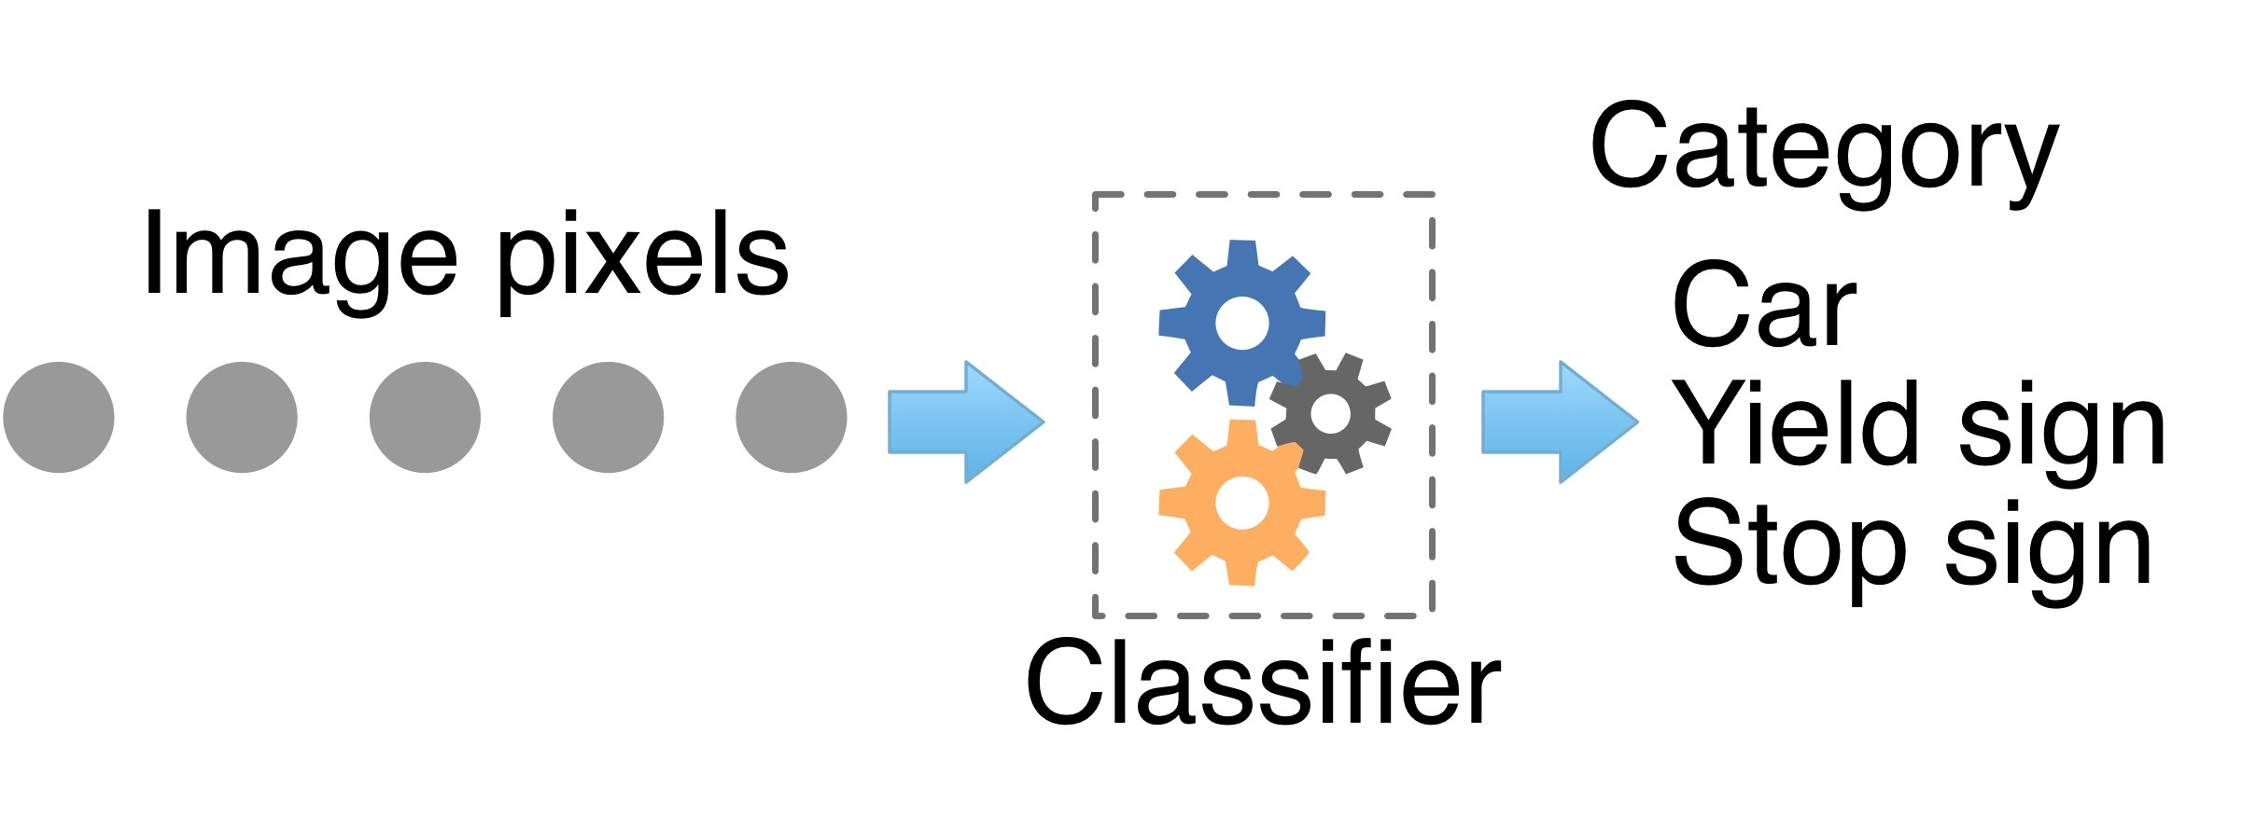

By following these steps and regularly assessing your smarter AI-powered spam classifier, you can ensure it remains effective and reliable over time. Continual monitoring and improvements are key to maintaining a high-quality spam detection system.

***PROGRAM***

***INPUT:***

*# Convert tokenized words back to text*

data['v2'] = data['v2'].apply(lambda x: ' '.join(x))

*# Initialize the Count Vectorizer*

count_vectorizer = CountVectorizer(max_features=5000)

*# You can adjust max_features as needed*

*# Apply the vectorizer to the 'v2' column*

features = count_vectorizer.fit_transform(data['v2'])

*# Convert the result to a dense array (if needed)*

features = features.toarray()

X_train, X_test, y_train, y_test = train_test_split(features, data['v1'], test_size=0.2, random_state=42)

classifer = MultinomialNB()

classifer.fit(X_train, y_train)y_pred = classifer.predict

(X_test)report = classification_report(y_test, y_pred)

print(report)

*# Assuming 'features' and 'data['v1']' are your features and*

*labels*X = featuresy = data['v1']

*# Perform 5-fold cross-validation (you can adjust 'cv' as needed)*

cv_scores = cross_val_score(classifer, X, y, cv=5)

*# Print the cross-validation scores*

print(f'Cross-Validation Scores: **{**cv_scores**}**')

print(f'Mean CV Score: **{**cv_scores.mean()**}**')

***OUTPUT:***

recision recall f1-score support

0 0.99 0.98 0.99 889

1 0.90 0.94 0.92 145

accuracy 0.98 1034

macro avg 0.94 0.96 0.95 1034

weighted avg 0.98 0.98 0.98 1034

Cross-Validation Scores: [0.97969052 0.97582205 0.97582205 0.9787234 0.9767667 ]

0.9773649452028887

***INPUT:***

classifier.fit(X_train, y_train)y_pred = classifier.predict

(X_test)report = classification_report(y_test, y_pred)

print(report)

*# Assuming 'features' and 'data['v1']' are your features and*

*labels*X = featuresy = data['v1']

*# Perform 5-fold cross-validation (you can adjust 'cv' as needed)*

cv_scores = cross_val_score(classifer, X, y, cv=5)

*# Print the cross-validation scores*

print(f'Cross-Validation Scores: **{**cv_scores**}**')

print(f'Mean CV Score: **{**cv_scores.mean()**}**')

***OUTPUT:***

precision recall f1-score support

0 0.98 1.00 0.99 889

1 0.98 0.90 0.94 145

accuracy 0.98 1034

macro avg 0.98 0.95 0.97 1034

weighted avg 0.98 0.98 0.98 1034

Cross-Validation Scores: [0.97969052 0.97582205 0.97582205 0.9787234 0.9767667 ]

0.97736494520288

***INPUT:***

_, ax=plt.subplots(3,1,figsize=(15,10))

sns.histplot(df[df.target==0]['sentences_count'],

ax=ax[0], binwidth=1)

sns.histplot(df[df.target==1]['sentences_count'], color='red', ax=ax[0], binwidth=1)

sns.histplot(df[df.target==0]['words_count'],

ax=ax[1])

sns.histplot(df[df.target==1]['words_count'], color='red',

ax=ax[1])

sns.histplot(df[df.target==0]['characters_count'],

ax=ax[2])

sns.histplot(df[df.target==1]['characters_count'], color='red', ax=ax[2])

***OUTPUT:***

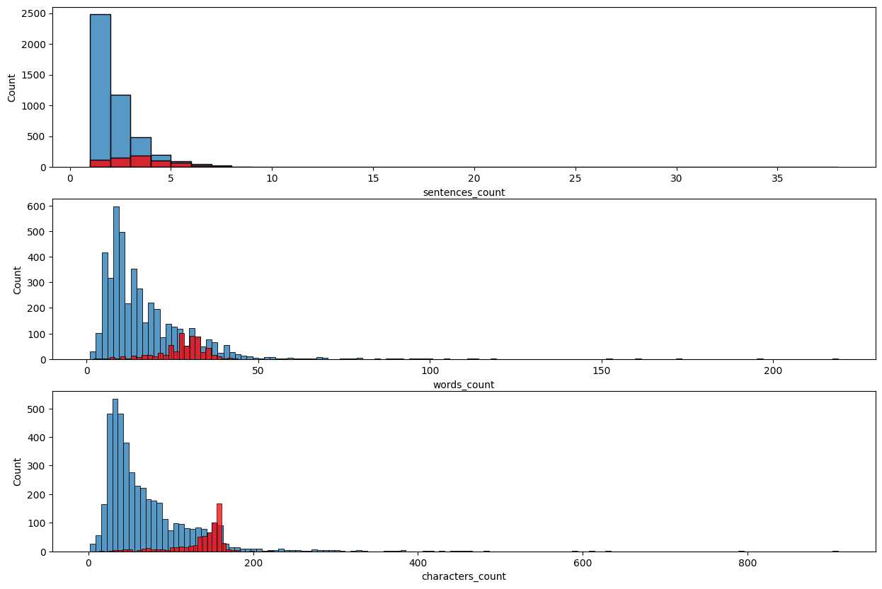

***INPUT:***

sns.pairplot(df, hue='target')

self._figure.tight_layout(*args, **kwargs)

***OUTPUT:***

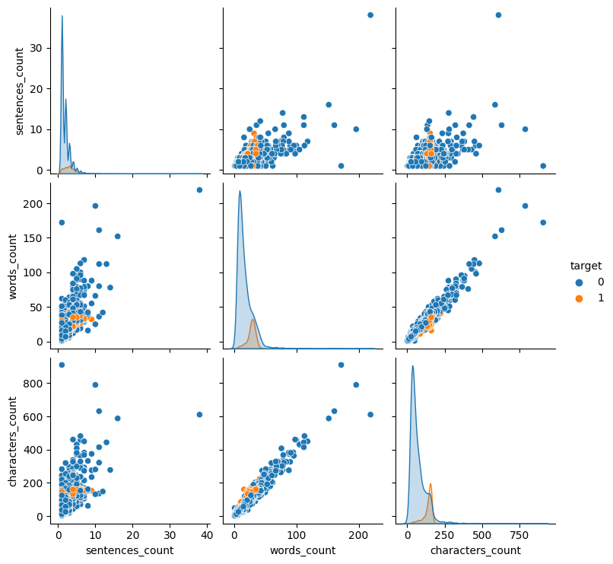

***INPUT:***

def test_models(models):

scores = {'model': [],

'accracy score': [],

'precision score': []}

_, ax = plt.subplots(1, len(models), figsize=(20,5))

for index, model **in** enumerate(models):

model.fit(X_train, y_train)

y_pred = model.predict(X_test)

accuracy = accuracy_score(y_test, y_pred)

precision = precision_score(y_test, y_pred)

scores['model'].append(type(model).__name__)

scores['accracy score'].append(accuracy)

scores['precision score'].append(precision)

sns.heatmap(confusion_matrix(y_test, y_pred), annot=True, ax=ax[index], fmt=".0f")

ax[index].set_title(type(model).__name__)

scores = pd.DataFrame(scores)

return scores

models = [

GaussianNB(),

BernoulliNB(),

MultinomialNB(),]scores = test_models(models)

***OUTPUT:***

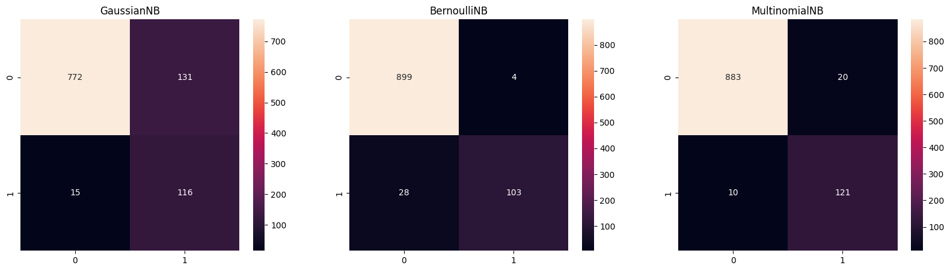

***Conclusion:***

***Building a Smarter AI-Powered Spam Classifier***

The relentless onslaught of spam in our digital lives poses a persistent challenge that demands innovative solutions. In the pursuit of building a smarter AI-powered spam classifier, we've navigated a path that combines the power of artificial intelligence with comprehensive data strategies and ethical considerations. As we conclude this journey, it's clear that the development of intelligent spam filters is not merely a technological endeavor; it's a crucial element in maintaining the integrity, security, and efficiency of digital communication.

***Key take aways from our exploration:***



1. ***AI's Transformative Role:***

Artificial intelligence, encompassing machine learning and deep learning, has ushered in a new era of spam classification. These technologies endow us with the adaptability and intelligence necessary to combat ever-evolving spam tactics.

1. ***The Data Foundation:***

The quality and quantity of data are foundational to building an effective spam classifier. A well-curated dataset, representing both spam and legitimate messages, is essential for success.

1. ***Model Diversity:***

The selection of the right algorithm or architecture is pivotal. Experimentation and careful model selection ensure that your system is well-equipped to meet the challenges of spam classification.

1. ***Fine-Tuning for Precision:***

Hyperparameter optimization and the choice of evaluation metrics are critical for achieving high precision in spam classification. Balancing false positives and false negatives is a delicate yet necessary task.

1. ***Generalization and Privacy:***

Guarding against overfitting and addressing privacy concerns are intertwined. Regularization techniques, ethical data handling, and bias mitigation are essential.

1. ***User-Centric Approach:***

User feedback and continuous improvement through monitoring are vital components of a successful spam classifier. Real-world adaptation is an ongoing journey.

1. ***Deployment and Scalability:***

A well-executed deployment strategy ensures that your system integrates seamlessly into a production environment. Scalability and security considerations are essential as your user base grows.

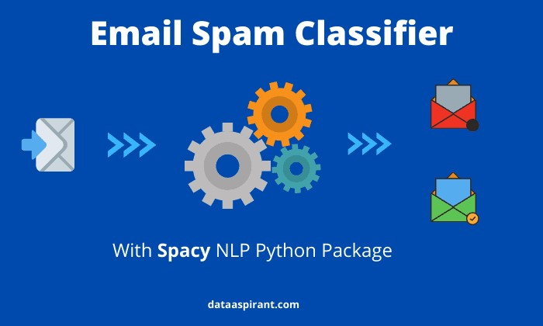

In conclusion, building a smarter AI-powered spam classifier represents a dynamic response to the ever-changing landscape of digital communication. It serves not only to declutter inboxes but also to safeguard the quality and security of our digital interactions. As you embark on your own journey to develop intelligent spam filters, keep in mind that this is not just a technical achievement; it's a service to a more secure, efficient, and user-centric digital world. By continually refining and adapting your system, you contribute to a cleaner, safer, and more enjoyable digital environment for all.

***\*\*\*\*\*THANKING YOU\*\*\*\*\****